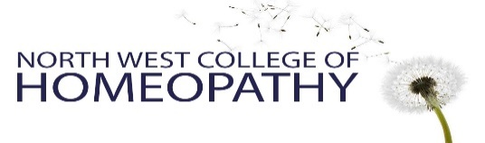
Please attach a recent photograph of yourself here

Application Form
2022-2023

Four-year professional course in Homeopathy &
One-year Foundation course in Homeopathy

Name:
Address:
Telephone:
Email:

We interview all applicants, ideally in person. This form is to give us some preliminary information for that conversation. Please type freely in the boxes provided.

Are you applying for the one year or the four year course?

Please tell us your experience of Homeopathy and why you would like to study it.

Please tell us about your Education level and learning experience to date. Formal or Informal. (Life and work experience are equally as important as academic study Please let us know anything that you think is relevant)

Is there any information that you would like to tell us about your personal circumstances? For example – mobility.

How did you hear about the North West College of Homeopathy?

Declaration:

- I confirm that I have had no convictions for sexual offences, or abuse of children or vulnerable adults
- I am over 21 years of age
- I currently have the right to live and study in the UK for the duration of the course applied for. (please note, we are unable to assist with any visa applications)

- Signed: Date:

We invite you to join us for a College Open day, where you will meet staff and students and have the opportunity to ask any questions. Please see our website for available dates at www.nwch.co.uk. You can also contact us on info@nwch.co.uk or 0161 731 0148.

Applications can be emailed to info@nwch.co.uk or posted to the address below. We will then contact you to arrange an interview.

- If possible please attach an electronic signature if emailing. If not, you can sign a hard copy at your interview.

Correspondence address –
North West College of Homeopathy
134 Nicolas Rd
Chorlton
Manchester
M21 9LT

